**CUSTOMER RETENTION**

How do you analyze customer retention?

Conducting a customer retention analysis is much more than calculating the churn rate.  
...

1. Choose retention KPIs. ...
2. Flag behaviors that indicate churn risk for at-risk customers. ...
3. Determine churn triggers for each cohort & persona. ...
4. Identify behaviors associated with churn and retention. ...
5. Get direct feedback from customers.

**Retention analysis using customer engagement score**

1. Identify key events and define what engagement means for your product.
2. Assign an engagement score to each completed event.
3. Calculate the event value for each event (multiply the event value by the number of times the user performs that action)

## What is retention analysis?

Retention analysis allows you to understand customer behavior when it comes to using and abandoning your product so you can maintain healthy growth through constantly improving retention.

Tracking customer behavior will get you insights into :

* What’s the average [customer lifecycle](https://userpilot.com/blog/customer-lifecycle-marketing-guide/)?
* What’s your customer retention rate?
* What customer segments churn within the first months?
* What makes customers stick around longer?
* How to improve [users’ satisfaction](https://userpilot.com/blog/improve-customer-satisfaction-saas/) and reduce customer churn.

## What does a retention analyst do?

A retention analyst is responsible for sustainable business growth by retaining customers. Their goal is to figure out why users are leaving the product and how to prevent it.

Among their tasks are:

* Work with large data set of [customer behavior analytics](https://userpilot.com/blog/customer-behaviour-analytics/) to understand churned customer behavior.
* Measure user [stickiness](https://userpilot.com/blog/increase-product-stickiness-saas/) around the product (how many customers return to your product because it’s engaging and valuable to them).
* Design and implement customer retention strategies that increase the customer lifetime value.

## How do you measure retention?

Every product faces churn. It’s inevitable. Sometimes users sign-up just to hang around for five minutes or buy the cheapest plan to solve a one-time task, then never return.

Yet our goal is to increase the number of customers who continue to use your product month after month.

Before starting to analyze customer retention, you first need to understand what customer success looks like for your users using your product.

Let’s learn how to prepare proper data sets for accurate retention analysis.

### Define active vs. inactive users

The first step toward customer retention analysis is defining what inactive users are and excluding them.

This will help you focus your analysis on [power users](https://userpilot.com/blog/in-app-training-saas/).

Just for recalling:

* [Active users](https://userpilot.com/blog/how-to-increase-monthly-active-users/) are those who constantly engage with your core product features and have a high customer engagement score.
* [Inactive users](https://userpilot.com/blog/reengage-inactive-users-saas/)remain are the ones who suddenly stop engaging with your product.

Defining what active means will be different depending on your product and how it was meant to be used.

For example, if you have an invoicing tool, you won’t count active users based on the number of logins, as the user might only need to issue one invoice in a month.

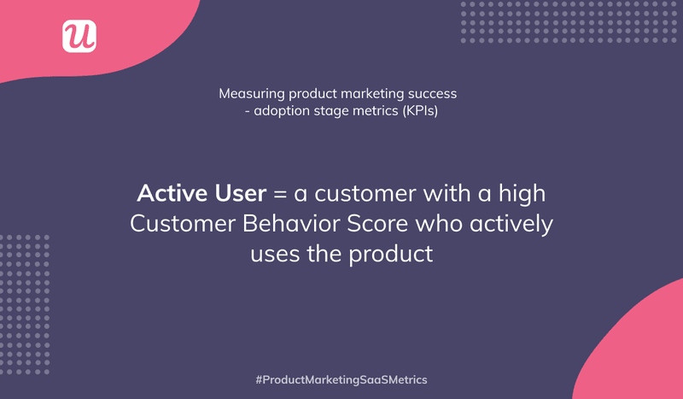

The definition of the active user

### Understand engagement

Active users also mean engaged users. But what are the features they are mostly engaging with?

Once you understand this, you pretty much understand what’s bringing value to them.

A user getting value from your product is going to return and continuously take the same actions that brought him value.

You’ll want to track how users are performing those actions in your retention analysis.

### Calculate retention rate

Now that you understand entirely what active users stand for, you calculate the retention rate. This will be your starting point for what you will be looking to improve.

Divide the number of paying customers at the end of the time period (usually a month) by the total number of paying customers at the beginning of that period. Next, multiply the result by 100. Thus you will get the retention rate in percentage.

For example, 1375/1547×100 equal 89% (customer retention rate).